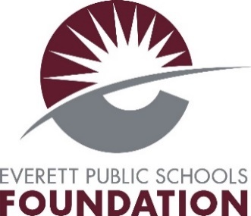

APPLICATION DEADLINE - ON OR BEFORE APRIL 24, 2025
The Kenneth clarke scholarship ($1250)
Applicant winners will be notified in May
INSTRUCTIONS: Complete application and give it to Mr. Dahlke in JHS Career Center. Attach your transcript (ask Mr. Dahlke for assistance.) and additional pages, if needed. Contact Mr. Dahlke with any questions (ddahlke@everettsd.org, 425-385-7028).

Eligibility: Kenneth Clarke, a 2017 JHS graduate, was involved in mock trials, international studies, interested in going into politics, and passionate about social justice and United Nations issues. This scholarship is intended to recognize:
- Applicant wants to change or impact the world, pursuing a path of one or more of the following: social justice, history, or international affairs/government/political science.
- Financial need of applicant is preferred by not mandatory.
- Student should show involvement in high school and/or local community.

School: Henry M. Jackson High School
Full Name:

First Middle Last

Address:
Street City State Zip

Phone #: Email:

College/University/Trade School/Technical School
Preference (if applicable)

First Choice:
Second Choice:

Post High School Goals

Education
Please list courses taken to support your goals.

Activities
Please list activities, accomplishments, hobbies, honors, and awards that support your application.

Written Essay
The Kenneth Clarke is a scholarship for students who support social justice, international affairs, government, and history, and who have financial need to attend academic and professional opportunities and training after high school. Kenneth, a 2017 JHS graduate, was involved in mock trials, international studies, interested in going into politics, and passionate about social justice and United Nations issues. This scholarship is intended to recognize a student who demonstrates thoughtful personal and systemic action and support for the greater good.
(Please limit to 500 words. Attach additional pages, if needed.)

